Name_____________________________________ Date_________________________________

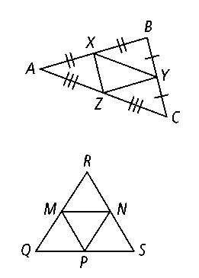

**8.1 – Simplifying Square Roots**

Simplify

|  |  |  |  |
| --- | --- | --- | --- |
| 1) | 2) | 3) | 4) |
| 5) | 6) | 7) | 8) |
| 9) | 10) | 11) | 12) |

|  |  |  |
| --- | --- | --- |
| 13) | 14) | 15) |
| 16) | 17) | 18) |

|  |  |  |  |  |  |
| --- | --- | --- | --- | --- | --- |
| 19) | 20) | | 21) | | 22) |
| 23) | | 24) | | 25) | |
| 26) | | 27) | | 28) | |
| 29) | | 30) | | 31) | |

|  |  |  |  |
| --- | --- | --- | --- |
| 32) | 33) | 34) | 35) |
| 36) | 37) | 38) | 39) |

Find the square root of each number by using the calculator. Round your answer to the nearest tenth.

|  |  |  |
| --- | --- | --- |
| 40) 56 | 41) 12 | 42) 92 |